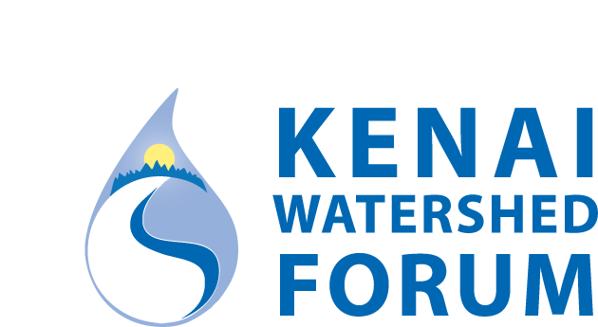

2018 Summer Job Opening

The Kenai Watershed Forum is seeking applicants for a Summer Day Camp Assistant.

Assistant will be responsible for organizing and maintaining camper paperwork, assisting leader during camp hours as needed, securing camp supplies, and other camp related duties as assigned.

Campers will be on-site from June 11 – August 4, Monday through Friday, 8am to 4pm. Week of July 4th there is no camp, but possibility of prep/clean-up projects during that week exist.

Start date: June 4 (or earlier if approved)
During camp weeks Assistant will work 8 hours/day,
During off weeks, set-up, clean-up or work as needed.
Wage: $11/hour

Applicants must be 18 or older, have experience working with children, have reliable transportation, maintain a clean driving record, comfortable in the outdoors for extended periods of time, able to hike up to 5 miles unassisted, and pass a background check.

To apply, please submit a one page letter of interest and a one page resume to: rhonda@kenaiwatershed.org

Applications will be accepted until 5pm May 3, 2018.

The Kenai Watershed Forum is a 501(c)(3) tax-exempt institution (Tax ID #91-1829284)

